Project Planning Phase
Product Backlog, Sprint Planning, Stories, Story Points
Date | 01 November 2026
Roll Number | 323103282099
Project Name | Incident Lifecycle Automation in ServiceNow
Maximum Marks | 5 Marks

Product Backlog, Sprint Schedule, and Estimation
I broke the work into 18 user stories across 4 sprints. Story points follow the Fibonacci scale: 1 for a very easy task, 2 for a normal one, 3 for a moderate one and 5 for a difficult one.
Sprint | Functional Requirement (Epic) | Story No. | User Story / Task | Story Points | Priority | Team Member
Sprint-1 | Setup | USN-1 | Create users (Service Agent, L2 Technician) with the itil role | 2 | High | Tejaswi
Sprint-1 | Setup | USN-2 | Create assignment groups and add members | 2 | High | Tejaswi
Sprint-1 | Knowledge | USN-3 | Create and publish a knowledge article in the IT knowledge base | 3 | High | Tejaswi
Sprint-1 | Service hierarchy | USN-4 | Create the Remote Access service and Corporate VPN offering | 2 | High | Tejaswi
Sprint-1 | SLA | USN-5 | Create an SLA definition and check Task SLAs | 3 | Medium | Tejaswi
Sprint-2 | Incident creation | USN-6 | Log the VPN incident in Service Operations Workspace as Beth Anglin | 2 | High | Tejaswi
Sprint-2 | Classification | USN-7 | Classify as Network / VPN with Remote Access, Corporate VPN and a CI | 3 | High | Tejaswi
Sprint-2 | Knowledge integration | USN-8 | Attach an article with Agent Assist and mark it helpful | 3 | High | Tejaswi
Sprint-2 | Collaboration | USN-9 | Add Samantha Bordwell to the watch list and Beth Anglin to the work notes list | 2 | Medium | Tejaswi
Sprint-3 | Level 2 tracking | USN-10 | David Loo (Level 2) assigns the incident to himself | 2 | High | Tejaswi
Sprint-3 | Level 2 tracking | USN-11 | Update the CI to PowerEdge and set On Hold, Awaiting Change | 2 | High | Tejaswi
Sprint-3 | Emergency change | USN-12 | Create the emergency change and link the incident | 5 | High | Tejaswi
Sprint-3 | Child incidents | USN-13 | Create a child incident and check it under the parent | 3 | Medium | Tejaswi
Sprint-4 | Resolution | USN-14 | Add cause and resolution, then resolve the parent | 3 | High | Tejaswi
Sprint-4 | Knowledge creation | USN-15 | Create a knowledge article from the resolved incident | 3 | High | Tejaswi
Sprint-4 | SLA | USN-16 | Verify SLA tracking in Task SLAs | 2 | Medium | Tejaswi
Sprint-4 | Testing | USN-17 | End-to-end validation and role checks | 3 | High | Tejaswi
Sprint-4 | Demonstration | USN-18 | Record the demo video and prepare the documents | 2 | Medium | Tejaswi

Project Tracker, Velocity & Burndown Chart

Project Tracker
Sprint | Total Story Points | Duration | Sprint Start Date | Sprint End Date (Planned) | Story Points Completed (as on Planned End Date) | Sprint Release Date (Actual)
Sprint-1 | 12 | 6 Days | 13 Oct 2026 | 18 Oct 2026 | 8 | 31 Oct 2026
Sprint-2 | 10 | 2 Days | 01 Nov 2026 | 02 Nov 2026 | 10 | 02 Nov 2026
Sprint-3 | 12 | 2 Days | 02 Nov 2026 | 03 Nov 2026 | 12 | 03 Nov 2026
Sprint-4 | 13 | 1 Day | 03 Nov 2026 | 03 Nov 2026 | 13 | 03 Nov 2026

Sprint-1 ran late. The knowledge article I created was held in Review because the IT knowledge base used the "Approval Publish" flow, and the approval went to the knowledge base owner instead of me. Once I approved it, the remaining 4 points were closed and the other sprints finished on time.

Velocity
Velocity tells us how many story points get done in one sprint on average:
Velocity = Total story points completed / Number of sprints = (12 + 10 + 12 + 13) / 4 = 47 / 4 = 11.75
So my average velocity was about 11.75 story points per sprint.

Burndown Chart
A burndown chart compares the work left with the time left. The dashed line is the ideal pace and the blue line is what actually happened.
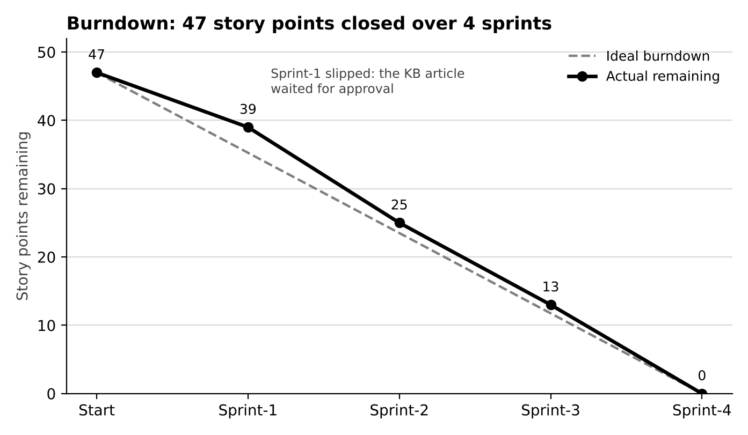
Figure 1: Burndown chart (story points remaining after each sprint)
The actual line sits a little above the ideal one after Sprint-1 because of the approval delay, then catches up and reaches zero by the end of Sprint-4.

